Database program

Functionality

The program’s purpose is to allow the user to manipulate a text file acting as a table within the database. Its purpose is to read in a file and create a table from the file. From there the program allows the user to –

* Add row
* Delete row
* Update item’s column value/Change/Delete
* Add column to table
* Delete column from table
* Update all the changes to the text files AKA write it into the text file.
* Change table name
* Change filename

The database class will be the class that will be upkeeping the tables. And the table class will be up keeping the individual items(“rows”) within the table. Apart from the main function the program should be able to –

* Keep a logger text file of movements within the program

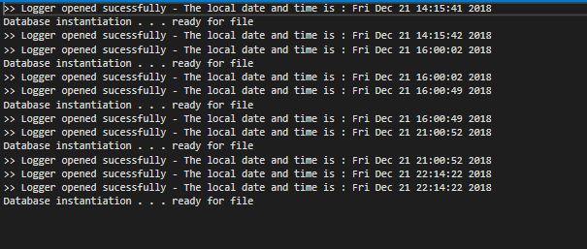

* Keep a text file of existing “tables”. A sample of this text file is below and the “table” text files.

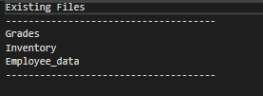 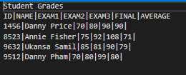

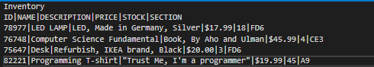

* Create a new “table” if the user so chose. When added the new text file name is added to the existing file’s list. And the database.

1. Allows user to pick from existing files.

* List out on console what the existing files are and let the user choose which file they would like to change.

1. Allows user to make new files.
2. After making changes, update all the text files. This step is like “Saving”.
3. Shut Down the Program

